**ASSIGNMENT-5.2**

**TASK-1:**

**Prompt:**

#write python program to develop a simple student login system that takes input username and password.

**Code with Output:**

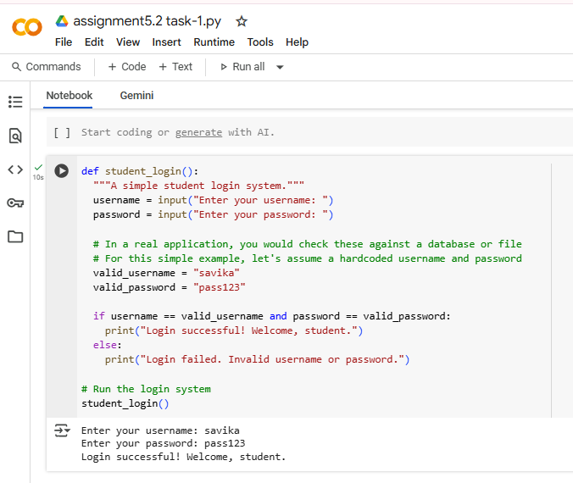

**Explanation:**

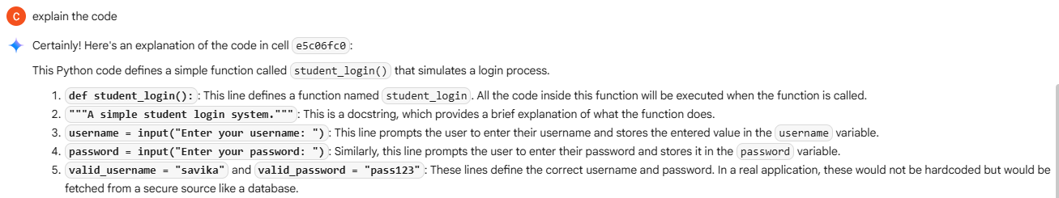

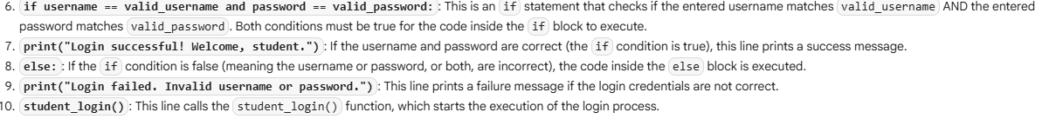

**TASK-2:**

**Prompt:**

#write a python program to develop a simple loan approval system with name, income, credit score, dept to income ratio.

**Code with Output:**

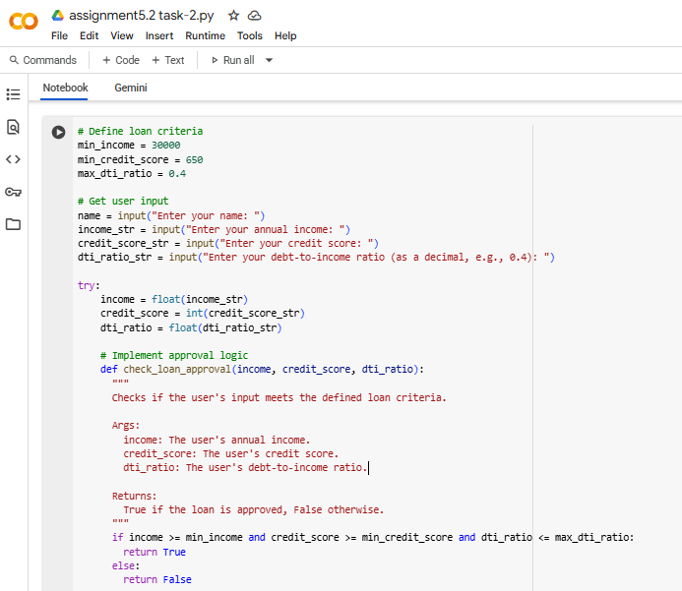

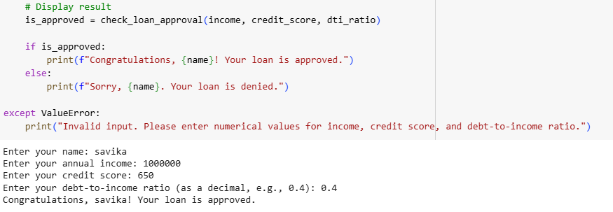

**Explanation:**

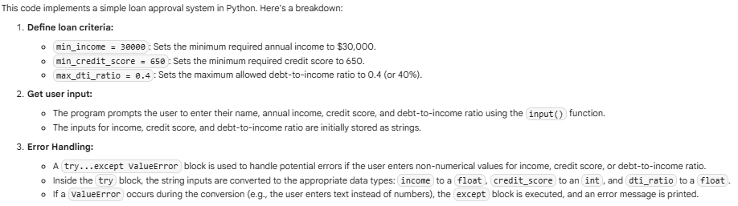

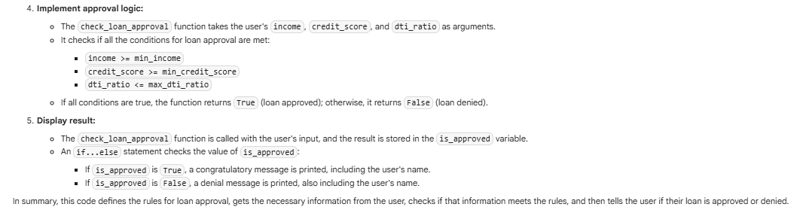

**TASK-3:**

**Prompt:**

#write a python program to calculate the nth Fibonacci number using recursion and using functions.

**Code and Output:**

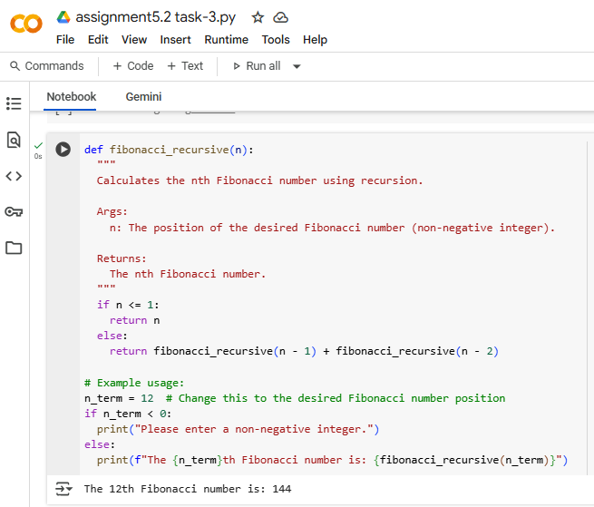

**Explanation:**

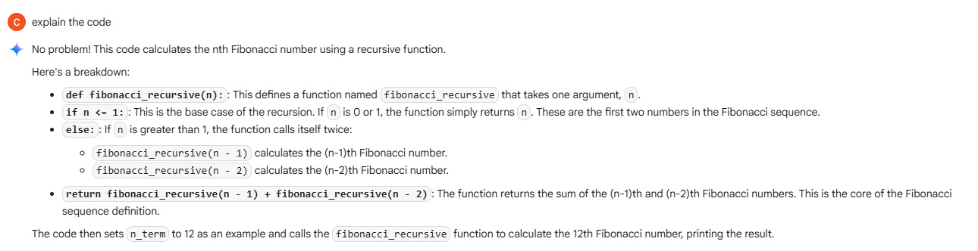

**TASK-4:  
Prompt:**

#write a python program to generate a job applicant scoring system based takes input education, experience, gender, age.

**Code with Output:**

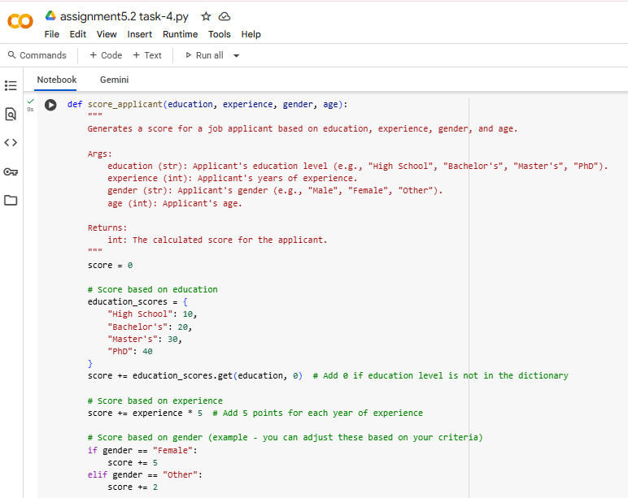

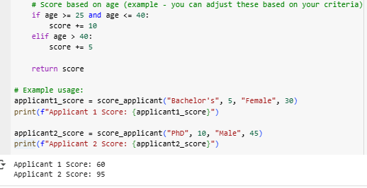

**Explanation:**

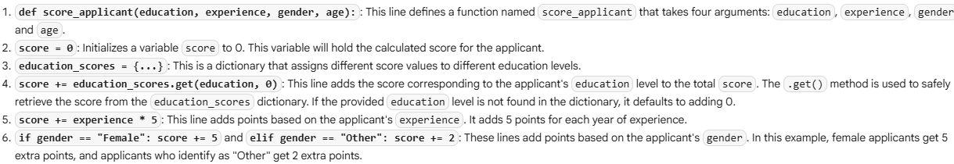

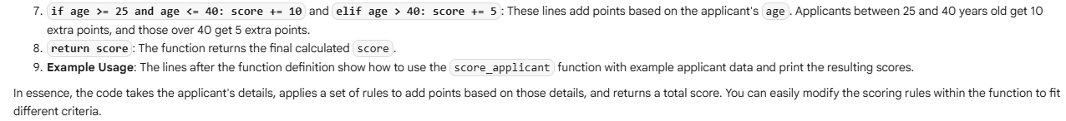

**TASK-5:  
Prompt:**

#write a python program to regenerate a code into gender-neutral.

**Code with Output:**

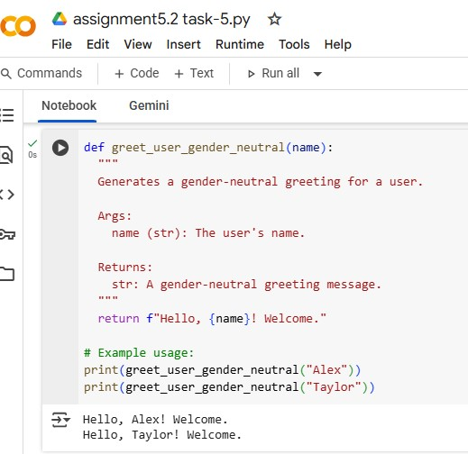

**Explanation:**

